**Web App Module**

One Page Document

**Project Title: Electronic & Home Appliances (eMart)**

**About System:**

Electronic & Home Appliances Merchandize Store is the Simple shopping Solution. It's a full-featured website with all product details and a shopping cart system that bends over backward to give you the flexibility you need to run your online store.

The basic concept of the application is to allow the customer to shop virtually using the Internet and allow customers to buy the items and articles of their desire from the store.

**Talking about the features of this system:**

* The admin can manage the users, products, inventory, and check subscribers.
* While the user can shop for all the available shopping items by signing in. And, in order to buy products online, he/she has to sign up/in through the system.
* The user can shop for multiple items and pay online through cards or COD. Here users have a facility to mail to the admin and chat with other users.
* The system will host a “Discussion Board” in which users can post new questions on available topics and can also post replies to existing questions.

**Stakeholders:**

A Stakeholder is a person or a group that has an interest in an organization’s activity. There are many different stakeholders in the eMart Merchandize Store. Some of the main stakeholders are the buyers and Vendors/Sellers.

1. **Buyers**: They can easily shop online and able to buy products overseas
2. **Vendors/Seller**: They can sell products online without a store.

**Features of the Online Merchandising Store**

1. User Registration
2. User login system
3. Change password
4. Forgot password
5. Profile management system
6. Shopping cart
7. Wishlist
8. Order History
9. Mail Us
10. Group Chat
11. Discussion Board

**Features of Admin**

1. Inventory Management(Add,Update, Delete)
2. Order Management System
3. User Management
4. Category/ Sub Category Creation and many more

**Team Members & Roles:**

1. Bipin Singh (BackEnd Developer, Tester)
2. Bibek kr. Sah (BackEnd Developer, Tester)
3. Shubham Sharma (Designer, FrontEnd Developer)
4. Pranav Sharma (FrontEnd Developer)

**Technology Stacks and Tools to used**

**Language Used**: PHP

**Database**: NoSQL

**User Interface Design** : HTML, CSS, Bootstrap, JavaScript

**Software**: VSCode, TestComplete, DB Tool

**Hardware / Software Requirements**

**Processor**: Pentium or Higher

**Ram**: 312 MB or Higher

**Operating System**: Unix, Linux, Mac, Windows, etc.

Web Browser: Mozilla, Google Chrome, Opera, Microsoft Edge

**Use Case Diagram**

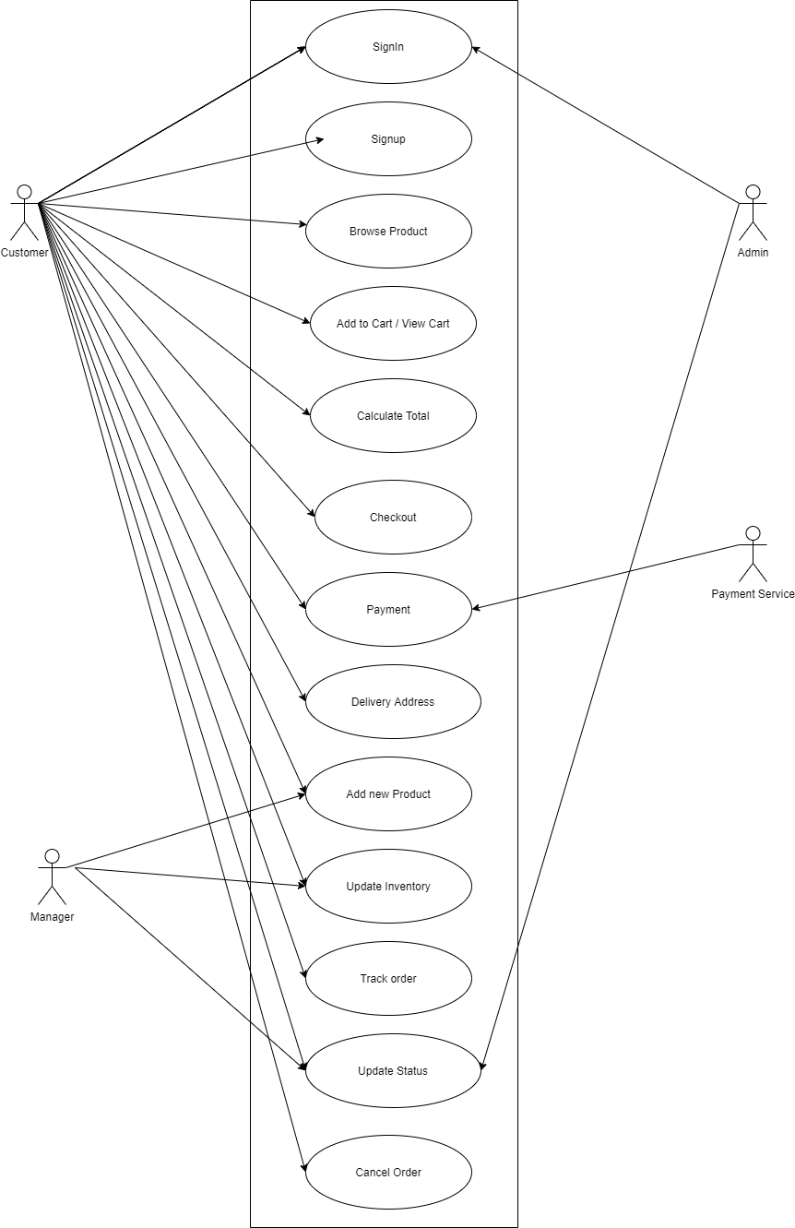

**ER Diagram**

